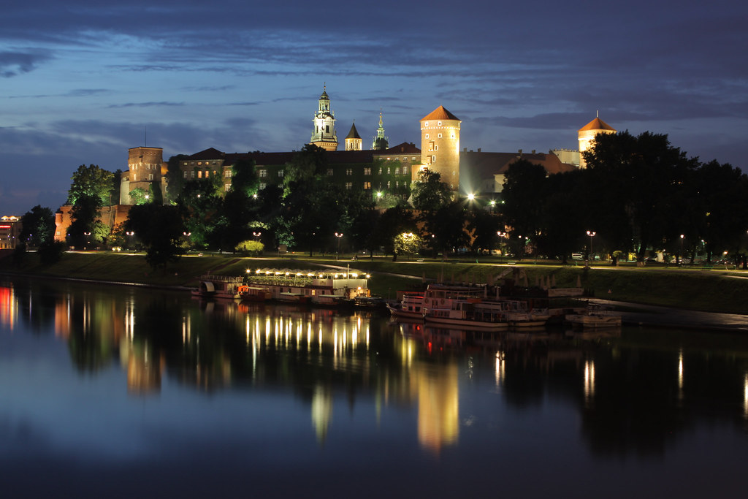

# Wawel Castle

The **Wawel Royal Castle** (Polish pronunciation: [[ˈvavɛl]](https://en.wikipedia.org/wiki/Help:IPA/Polish) [ⓘ](https://en.wikipedia.org/wiki/File:Pl-Wawel.ogg); *Zamek Królewski na Wawelu*) and the Wawel Hill on which it sits constitute the most historically and culturally significant site in [Poland](https://en.wikipedia.org/wiki/Poland). A fortified residency on the [Vistula River](https://en.wikipedia.org/wiki/Vistula_River) in [Kraków](https://en.wikipedia.org/wiki/Krak%C3%B3w" \o "Kraków), it was established on the orders of [King Casimir III the Great](https://en.wikipedia.org/wiki/Casimir_III_of_Poland)[[2]](https://en.wikipedia.org/wiki/Wawel_Castle#cite_note-2) and enlarged over the centuries into a number of structures around an [Italian-styled](https://en.wikipedia.org/wiki/Renaissance_in_Poland) courtyard. It represents nearly all European architectural styles of the [Medieval](https://en.wikipedia.org/wiki/Medieval), [Renaissance](https://en.wikipedia.org/wiki/Renaissance) and [Baroque](https://en.wikipedia.org/wiki/Baroque) periods.

The castle is part of a fortified [architectural complex](https://en.wikipedia.org/wiki/Built_environment) erected atop a limestone [outcrop](https://en.wikipedia.org/wiki/Outcrop) on the left bank of the [Vistula River](https://en.wikipedia.org/wiki/Vistula_River), at an altitude of 228 metres (748 ft) above sea level.[[3]](https://en.wikipedia.org/wiki/Wawel_Castle#cite_note-Wawel-3)[[4]](https://en.wikipedia.org/wiki/Wawel_Castle#cite_note-Urban-4) The complex consists of numerous buildings of great historical and national importance, including the [Wawel Cathedral](https://en.wikipedia.org/wiki/Wawel_Cathedral" \o "Wawel Cathedral) where Polish monarchs were crowned and buried. Some of Wawel's oldest stone buildings can be traced back to 970 CE, in addition to the earliest examples of [Romanesque](https://en.wikipedia.org/wiki/Romanesque_architecture) and [Gothic architecture](https://en.wikipedia.org/wiki/Gothic_architecture) in Poland.[[5]](https://en.wikipedia.org/wiki/Wawel_Castle#cite_note-5)[[6]](https://en.wikipedia.org/wiki/Wawel_Castle#cite_note-6) The current castle was built in the 14th century, and expanded over the next hundreds of years. In 1978, Wawel was declared the first [World Heritage Site](https://en.wikipedia.org/wiki/UNESCO_World_Heritage_Site) as part of the [Historic Centre of Kraków](https://en.wikipedia.org/wiki/Krak%C3%B3w_Old_Town).

For centuries the residence of the [kings of Poland](https://en.wikipedia.org/wiki/List_of_Polish_monarchs) and the symbol of Polish statehood, Wawel Castle is now one of the country's premier art museums.[[3]](https://en.wikipedia.org/wiki/Wawel_Castle#cite_note-Wawel-3) Established in 1930, the museum encompasses ten curatorial departments responsible for collections of paintings, including an important collection of [Italian Renaissance paintings](https://en.wikipedia.org/wiki/Renaissance), [prints](https://en.wikipedia.org/wiki/Printmaking), [sculpture](https://en.wikipedia.org/wiki/Sculpture), [textiles](https://en.wikipedia.org/wiki/Textiles), among them the [Sigismund II Augustus](https://en.wikipedia.org/wiki/Sigismund_II_Augustus) [tapestry](https://en.wikipedia.org/wiki/Tapestry) collection, goldsmith's work, [arms](https://en.wikipedia.org/wiki/Weapon) and [armor](https://en.wikipedia.org/wiki/Armor), [ceramics](https://en.wikipedia.org/wiki/Ceramics), [Meissen porcelain](https://en.wikipedia.org/wiki/Meissen_porcelain), and period furniture. The museum's holdings in [oriental art](https://en.wikipedia.org/wiki/Oriental_art) include the largest collection of Ottoman tents in Europe. With seven specialized conservation studios, the museum is also an important center for the conservation of works of art. With over 2.56 million visitors in 2023, Wawel Castle is the most visited art museum in Poland and the [20th most visited art museum in the world](https://en.wikipedia.org/wiki/List_of_most-visited_art_museums).

**Early history**The history of Wawel is deeply intertwined with the history of the Polish lands and Polish royal dynasties already in the [Middle Ages](https://en.wikipedia.org/wiki/Middle_Ages). The political and dynastic tensions that led to the ascendance of Kraków as the royal seat are sophisticated, but for most of the Middle Ages and the [Renaissance](https://en.wikipedia.org/wiki/Renaissance) Wawel was the seat of the national government and the [Diet (assembly)](https://en.wikipedia.org/wiki/Diet_(assembly)). As the [Polish–Lithuanian Commonwealth](https://en.wikipedia.org/wiki/Polish%E2%80%93Lithuanian_Commonwealth) formed and grew, Wawel became the seat of one of [Europe](https://en.wikipedia.org/wiki/Europe)'s largest and most important states. This status was only lost when the capital was moved to [Warsaw](https://en.wikipedia.org/wiki/Warsaw) in 1596 (designated officially in 1793)